USE CASE TEMPLATE
Use Case ID: | 1
Use Case Name: | Capture Marksheets
Created By: | Vamshi Bachu, Bharat Simha Reddy | Last Updated By:
Date Created: | 09-02-2024 | Date Last Updated:

Actors: | Users(University Administrators)
Description: | Users use their camera to captiure the image of marksheet.
Preconditions: | User must be logged into application.
Post conditions: | Image of marksheet is captured and ready for ocr processsing.
Normal Flow: | 1. User selects the "Capture Marksheets" option from the application's menu.  2. User activates the device's camera.  3. User aligns the camera to capture a clear image of the mark sheet.  4. User captures the image.  5. The captured image is displayed for review.  6. User confirms and processed to ocr engine
Alternative Flows: | If the image taken is blur, the user can retake the image
Exceptions:
Includes: | User Authentication
Priority: | High
Frequency of Use: | Frequently
Business Rules:
Assumptions: | Users have access to a device with functioning camera.

Refined use case diagram.

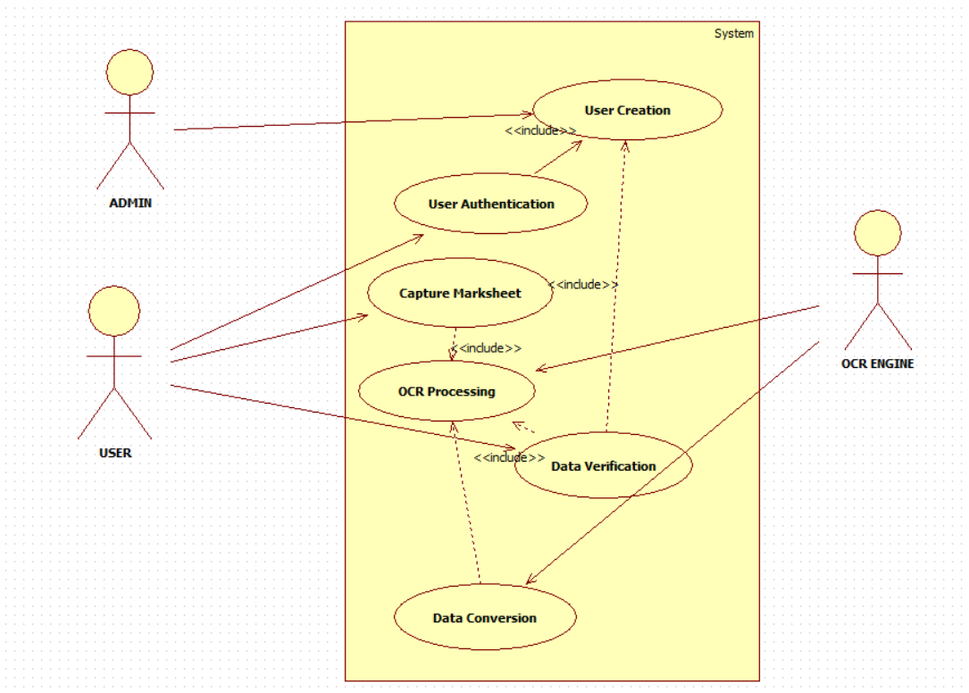

Activity Diagram for Capture Marksheets

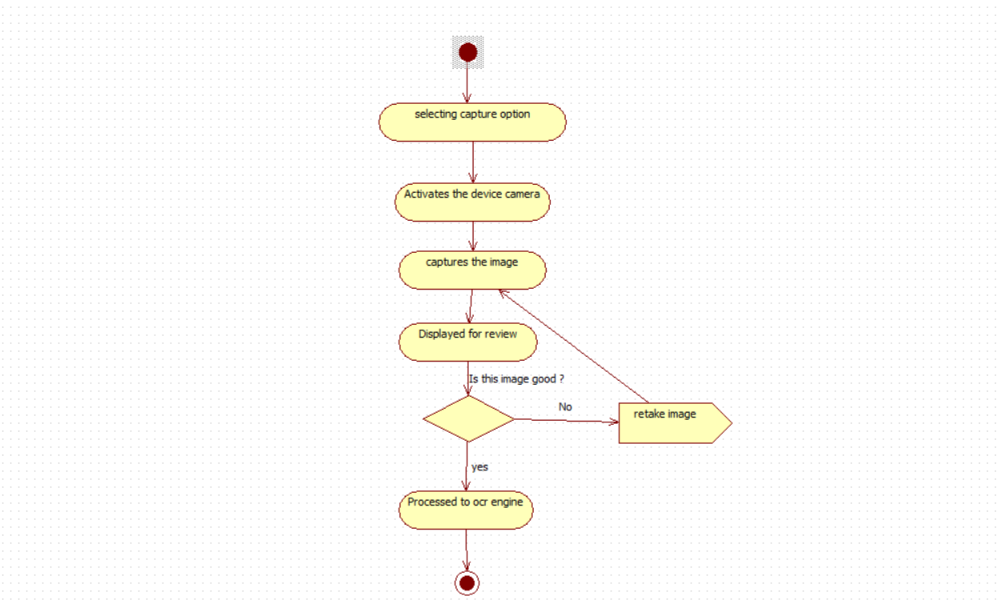

Sequence Diagram for Capture Marksheets
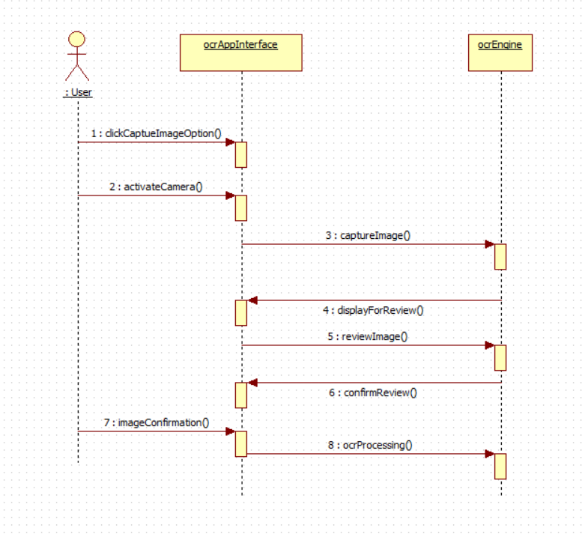

Use Case ID: | 2
Use Case Name: | User Authentication
Created By: | Vamshi Bachu, Bharat Simha Reddy | Last Updated By:
Date Created: | 19-02-2024 | Date Last Updated:

Actors: | Users(University Administrators )
Description: | the process of a user logging in to the OCR MARKSHEET application.
Preconditions: | - The user has created an account in the system.  - The user has a valid internet connection.  - The application is launched on a compatible device.
Post conditions: | - The user is successfully logged in to the application.  - The user has access to their account information and functionalities.
Normal Flow: | - The user opens the OCR MARKSHEET application.  - The login screen is displayed.  - The user enters their username and password.  - The application authenticates the credentials against the user database.  - If the credentials are valid:  - The user is granted access to the application.  - A session token is generated and stored securely.  - If the credentials are invalid:  - An error message is displayed.  - The user remains on the login screen.
Alternative Flows: | The user forgets their password and chooses the "Forgot Password" option.
Exceptions: | Server Issues
Includes: | Account Creation
Priority: | High
Frequency of Use: | frequent
Business Rules: | Two factor authentication.
Assumptions:

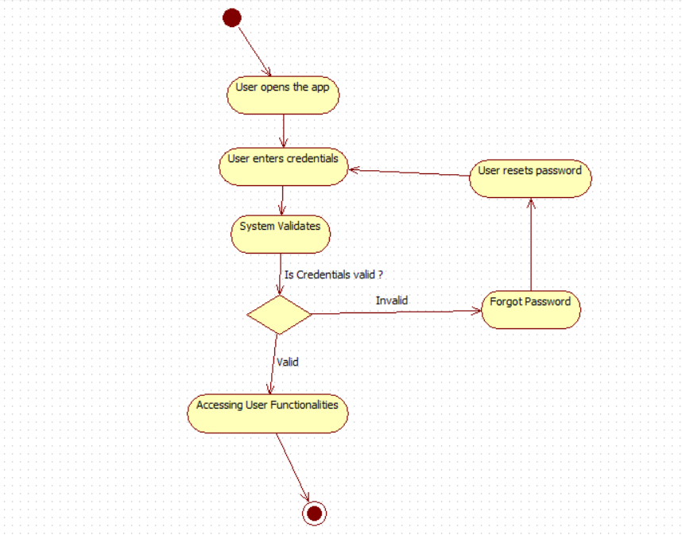

Activity Diagram for User Authentication

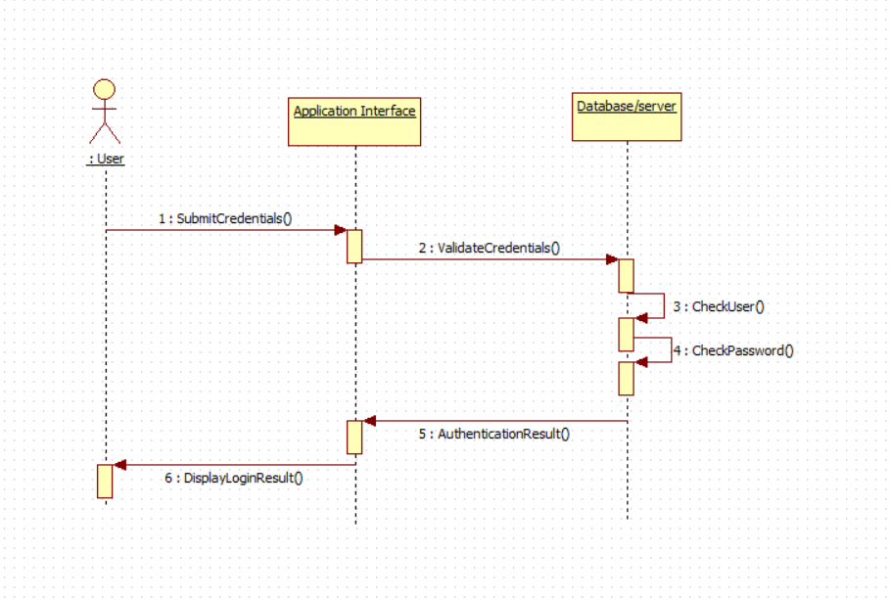
Sequence Diagram for User Authentication

Use Case ID: | 3
Use Case Name: | Data verification
Created By: | Vamshi Bachu,Bharat Simha reddy | Last Updated By:
Date Created: | 19-02-2024 | Date Last Updated:

Actors: | Users(University Administrators )
Description: | The process of a user verifying the data extracted from a marksheet image by the OCR engine.
Preconditions: | User has successfully captured and processed a marksheet image.  Extracted data from the image is displayed in a table format.
Post conditions: | User has reviewed and verified the extracted data.  User can proceed with data processing or saving.
Normal Flow: | - The application displays the extracted data in a user friendly format (table)  - The user compares the displayed data with the original mark sheet image.  - User can manually edit the errors in extracted data.  - User confirms the data is accurate and ready for further processing
Alternative Flows: | User could not able to verify the data.
Exceptions:
Includes: | Capture Marksheet, Data processing
Priority: | Low
Frequency of Use: | After image capturing
Business Rules:
Assumptions:

Activity Diagram for Data verification
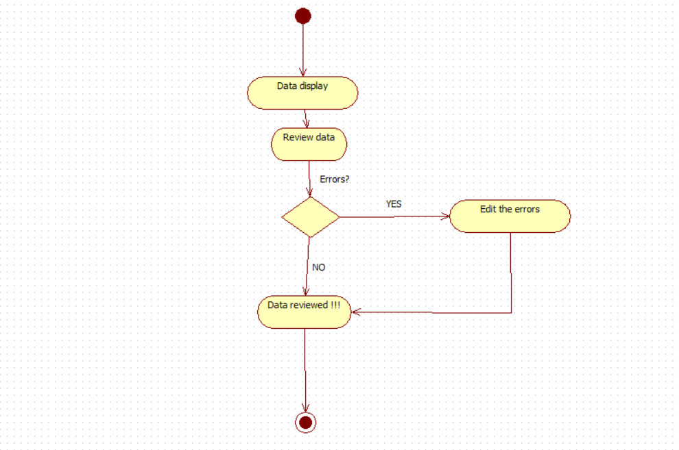

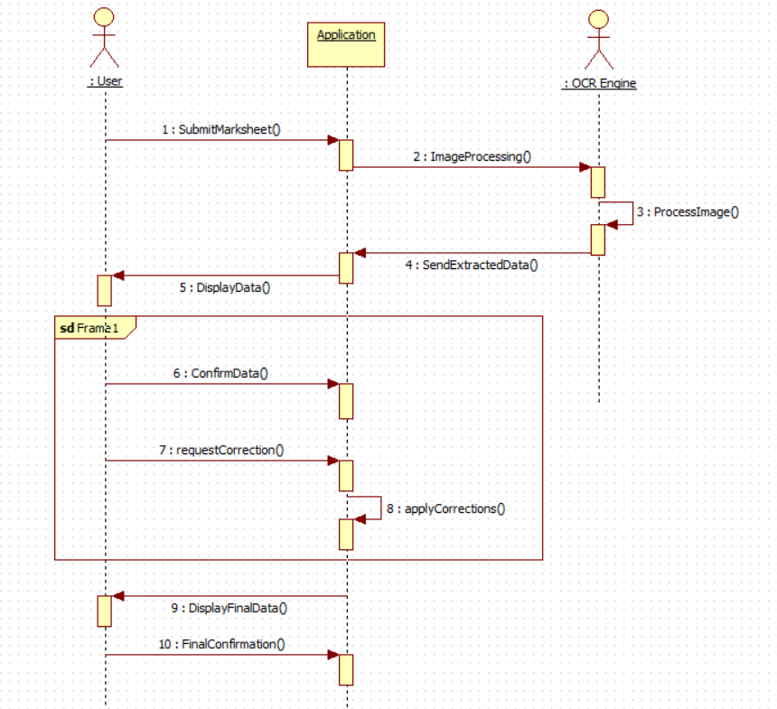
Sequence Diagram for Data verification

Use Case ID: | 4
Use Case Name: | OCR Processing
Created By: | Vamshi Bachu,Bharat Simha Reddy | Last Updated By:
Date Created: |  | Date Last Updated:

Actors: | OCR Engine
Description: | Extracting the information by processing the image.
Preconditions: | - User has a captured an image of a marksheet using applications camera.  - The image is uploaded to the server or processed locally.
Post conditions: | Extracted text data from the image, including student information and marks.
Normal Flow: | User selects the "Process Marksheet" option and uploads the image.  - The image is received by the OCR Engine.  - OCR Engine pre-processes the image for improved recognition (e.g., deskewing, noise reduction).  - Text is extracted from the image using OCR algorithms.  - Extracted text is parsed and structured into relevant data fields (e.g., student name, roll number, marks for each subject).  - Extracted data is validated for consistency and accuracy (e.g., checking for invalid characters, missing values).  - Processed data is displayed to the user in a table format.  - User can review and verify the extracted data.
Alternative Flows: | In accurate results due to poor quality of image.
Exceptions: | Ocr engine fails.
Includes: | Capture marksheet
Priority: | High
Frequency of Use: | Frequent
Business Rules:
Assumptions:

Activity Diagram for OCR Processing
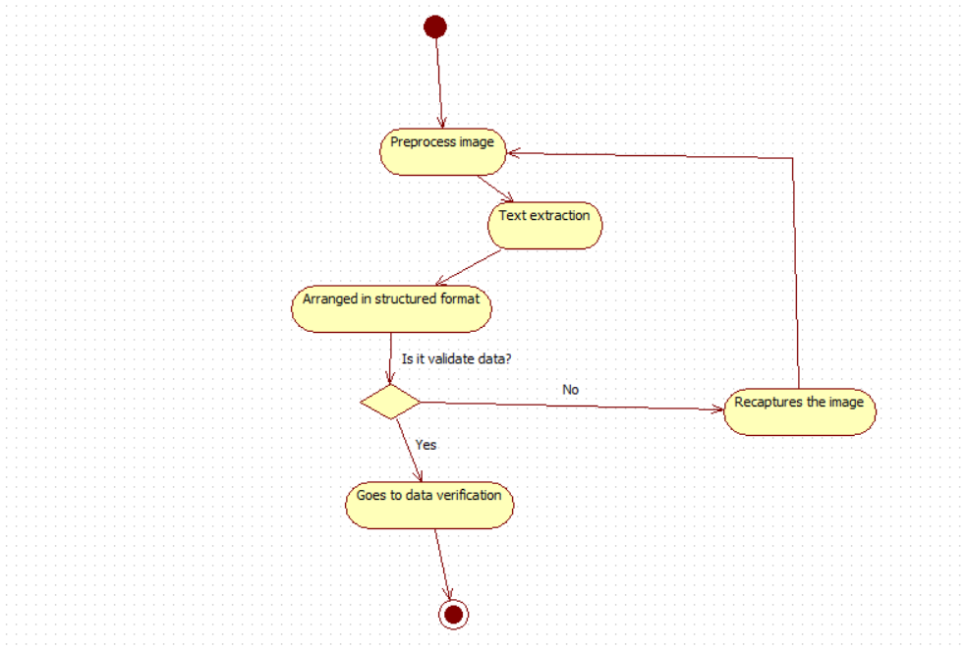

Sequence Diagram for OCR Processing

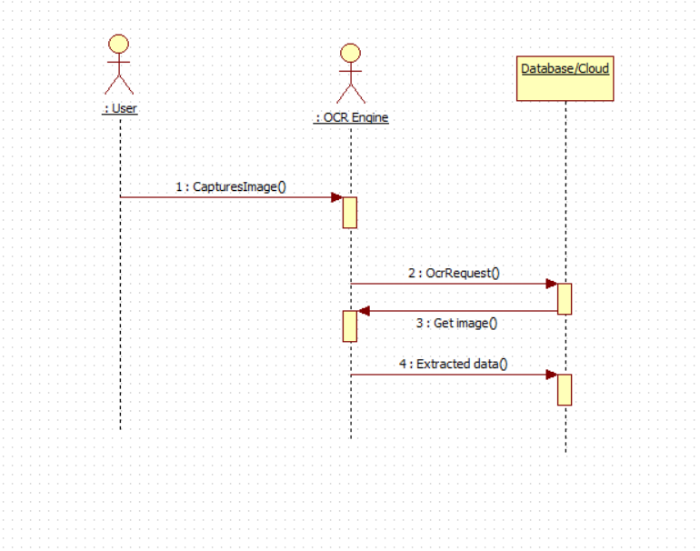

Use Case ID: | 5
Use Case Name: | Data Conversion
Created By: | Vamshi Bachu, Bharat Simha Reddy | Last Updated By:
Date Created: | 19-02-2024 | Date Last Updated:

Actors: | OCR-Engine, User
Description: | The process of converting extracted text data from a marksheet image into a structured table format.
Preconditions: | The OCR engine has successfully extracted text data from the marksheet image.
Post conditions: | The data is successfully converted into a structured format.
Normal Flow: | The Data Conversion Module performs data validation to ensure accuracy and consistency.  The converted table format is generated and sent back to the user.  The user reviews and verifies the converted data.
Alternative Flows:
Exceptions: | Technical issues
Includes: | Data Validation
Priority: | High
Frequency of Use: | Frequent (with each marksheet processing)
Business Rules:
Assumptions:

Activity diagram for Data Conversion
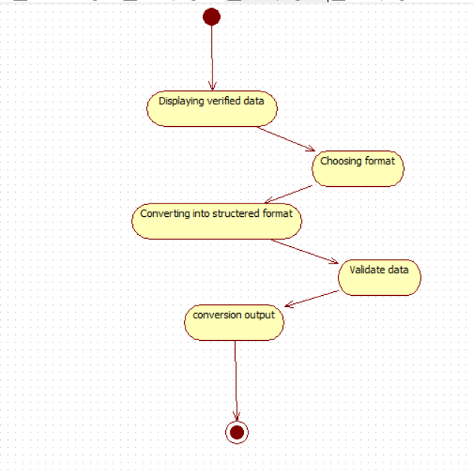

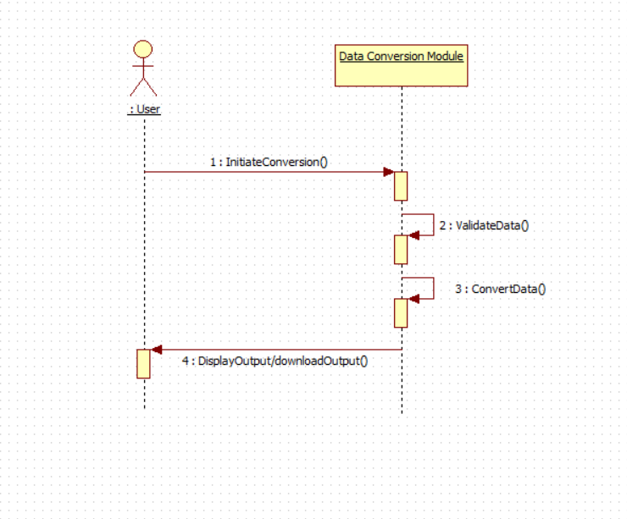
Sequence Diagram for Data Conversion

Use Case ID: | 6
Use Case Name: | User creation
Created By: | Vamshi Bachu, Bharat Simha Reddy | Last Updated By:
Date Created: | 19-02-2024 | Date Last Updated:

Actors: | Administrator
Description: | The process of an administrator creating a new user account in the OCR MARKSHEET application.
Preconditions: | The administrator has access to the "Create User" functionality.
Post conditions: | A new user account is created with the specified details.
Normal Flow: | The administrator selects the "Create User" option.  - The administrator enters the new user's information, including:  - Username  - Password  - Email address  - First name  - Last name  - Role (e.g., student, staff)  - (Optional) Additional user details as needed.  - The administrator chooses the initial application permissions for the new user based on their role.  - The administrator reviews the entered information and confirms creation.  - The system validates the information and creates the new user account.  - (Optional)An email notification with login credentials is sent to the new user's email address.
Alternative Flows: | The administrator enters invalid or incomplete information.
Exceptions:
Includes:
Priority: | Low
Frequency of Use: | Less
Business Rules:
Assumptions: | The administrator has accurate information about the new user.

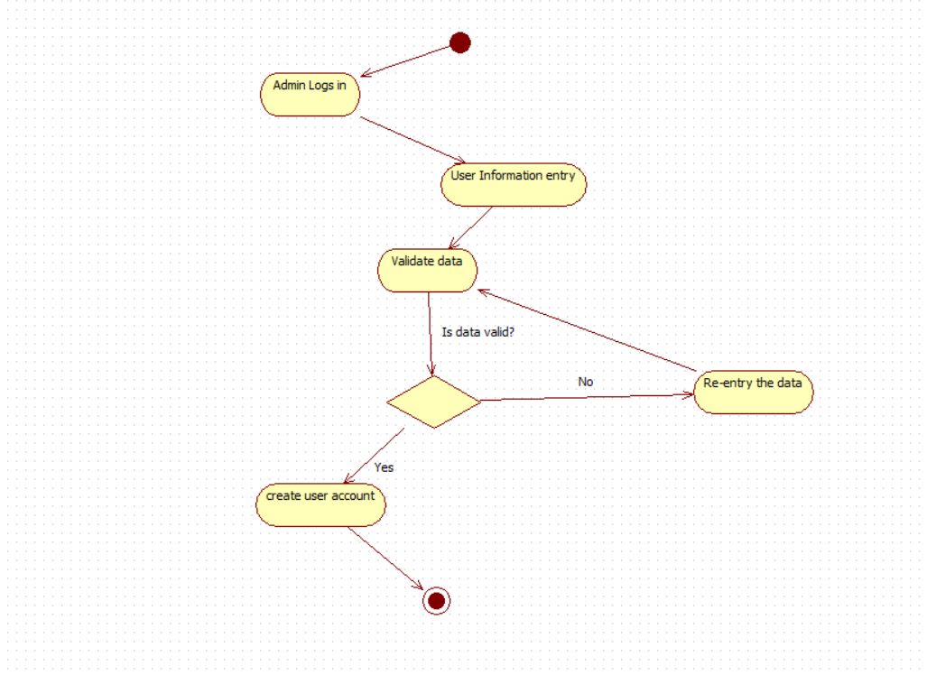
Activity Diagram for Data Conversion

Sequence Diagram for Data Conversion
